
FIELD TRIP REPORT TO KORLEBU TEACHING HOSPITAL.
FOR THE PROGRAMME OF STUDY OF BSc COMPUTER SCIENCE (CYBERSECURITY OPTION)
OF THE COMPUTER SCIENCE DEPARTMEN
OF GHANA COMMUNICATION TECHNOLOGY UNIVERSITY
BY
INDEX NO: 1704895585
NAME: EMMANUELLA NANA AMA WEIR

LECTURER: DR. MARTIN MABEIFAM UJAKPA.
JANUARY 2026.

Table Of Contents
List of Figures iii
List of Tables iv
Abstract v
1.1. INTRODUCTION 1
1.2. INDUSTRY: Health 1
1.3. COMPANY: Korle-bu Teaching Hospital 2
1.3.1. DEPARTMENT: IT/Health Information Systems 2
1.4. Operations, Activities and Resources. 2
1.4.1 Operational Effectiveness and Efficiencies of Korle-bu. 3
1.5. Operational Effectiveness and Efficiencies 3
1.5.1. Challenges 4
1.5.2. Analysis 4
1.5.3. Proposed Solution 5
1.5.4. Expected Benefits 5
1.6. Proposed Solution Specifications and Design 5
1.6.1. Appropriate Method: Agile Methodology 5
1.6.2. Requirement Analysis 6
1.6.2.1. Functional Requirements 6
1.6.2.2. Non-functional Requirements 6
1.6.2.3. Hardware Requirements 6
1.6.2.4. Software Requirements 7
1.6.2.5. Sprints and Iterations 7
1.6.2.6. User Stories 7
1.6.3. System Design 7
1.6.3.1. System Architecture Diagram 7
1.6.3.2. Use Case Diagram 8
1.6.3.3. Sequence Diagram 9
1.6.3.4. User Interface Design 9
1.7 Proposed solution development 10
1.7.1 Development technology and tools specifications 10
1.7.1.1 Software including programming language, IDE and runtime platforms 11
1.7.1.2 Hardware (development and production) 11
1.7.2 Network specifications and deployment considerations 11
1.7.2.2 Developed solution and associated code 12
1.8 System testing 25
1.8.1 Unit test 25
1.8.2 Integration testing 25
1.8.3 System testing 26
References 26

List of Figures
Figure 1 SYSTEM ARCHITECTURE 8
Figure 2 USE CASE DIAGRAM 8
Figure 3 SEQUENCE DIAGRAM 9
Figure 4 HEALTH CARE SECURITY DASHBOARD 12
Figure 5 COMPLETE SIEM VIEW 13
Figure 6 HEALTH CARE METRICS 13
Figure 7 CRITICAL-HEALTH-CARE-ALERTS 14
Figure 8 COMPLIANCE-STATUS 15
Figure 9 RANSOMWARE-DETECTION-DASHBOARD 16
Figure 10 HEALTH-CARE-SECURITY-RULES 17
Figure 11 ERH-ACCESS-MONITORING-RULES 18
Figure 12 AGENT-DEPLOYMENT-STATUS 19
Figure 13 MEDICAL-DEVICE-SECURITY 20
Figure 14 CONFIG-AGENT-WINDOWS 21
Figure 15 CONFIG-AGENT-LINUX 21
Figure 16 CONFIG-KIBANA 22
Figure 17 CONFIG-OPENSEARCH 22
Figure 18 CONFIG-WAZUH-LOCAL-DECODER 23
Figure 19 CONFIG-WAZUH-RULES-RANSOMWARE-RULES 23
Figure 20 CONFIG-WAZUH-RULES-LOCAL-RULES 24
Figure 21 CONFIG-WAZUH-RULES-HEALTH-CARE-RULES 24
Figure 22 PICTURE-OF-OTHER-FILES 25

List of Tables

Abstract
This report documents a field visit to Korle-bu Teaching Hospital with a focused assessment of the IT / Health Information Systems department and its information security posture. Observations and interviews identified a predominantly reactive security stance, limited real-time visibility across clinical devices and IT systems, and an absence of centralized log collection and correlation. These weaknesses expose sensitive patient data and critical services to an elevated risk of cyber incidents. To mitigate these risks the report recommends a phased SIEM implementation (SIEM-lite) based on proven components (for example, Wazuh or the Elastic Stack) with secure agents for telemetry capture, centralized parsing and normalization, correlation rules and automated alerting, and role-based dashboards for investigators and administrators. Development will follow an Agile delivery model with configuration-as-code, automated validation in CI/CD pipelines, and an incremental rollout prioritizing high-value log sources. The proposed deployment enforces secure network segmentation, TLS-protected log transport, strict RBAC and retention/handling practices aligned with Ghana’s Data Protection Act (Act 843). A comprehensive test plan covering unit, integration and system testing is included to validate functional, performance and security objectives prior to production cutover. Expected outcomes include reduced Mean Time to Detect and Mean Time to Respond (MTTD/MTTR), improved regulatory compliance evidence, reduced analyst workload and strengthened operational resilience for critical clinical services.

1.1. INTRODUCTION
Field trips form essential component to experiential learning within computing and cyber security. They provide students with the opportunity to observe how organizations operate in the real world operate, how technological processes are implemented, and how cyber security principles are applied within practical work environments. For students pursuing a Bachelor of Science in Cyber security, these visits bridge the gap between theoretical course work and industry practices, fostering a deeper understanding of organizational systems, digital operations and security challenges.
The purpose of this field trip exercise is to explore the structure, operations, and technological frameworks of selected firm in the Health Industry. By engaging directly with industry professionals and observing active technological systems, the exercise helps to highlight how organizations deploy, secure, and maintain their digital infrastructure. More importantly, It enables the identification of operational challenges and cyber security vulnerabilities.
This report focuses on one selected hospital within Health Industry named KORLE-BU TEACHING HOSPITAL and specifically examines its Information Security and Infrastructure Department. The content presented is based on observations made during the field visit, interactions with technical personnel, and an assessment of the hospital's operational structure and security practices. The report provides an overview of the industry, the firm, and the department understudy, leading to a detailed analysis of challenges observed and proposed solutions aligned with cyber security best practices

1.2. INDUSTRY: Health
The health industry in Ghana comprises public, private, and faith-based institutions that collectively deliver essential medical services to the population. This sector plays vital roles such as disease prevention, diagnosis, treatment, emergency response, maternal and child healthcare, and control of public health threats. In addition, health institutions are responsible for the management of patient information, including the accurate collection, storage, and protection of medical records and health data. Effective data handling supports clinical decision-making, improves service delivery, ensures continuity of care, and helps facilities meet regulatory standards for confidentiality and data security. Overall, the health industry remains central to safeguarding public health while maintaining reliable health information systems that support national development.

1.3. COMPANY: Korle-bu Teaching Hospital
Korle-bu Teaching Hospital is Ghana’s largest and premier referral hospital, located in Accra. Established in 1923, it serves as the main teaching hospital for the University of Ghana Medical School and plays a central role in training doctors, nurses, and other health professionals. As a tertiary facility, it provides highly specialized services such as cardiothoracic surgery, renal dialysis, oncology, plastic surgery, and advanced diagnostic care. The hospital also manages a large volume of patient information, ensuring proper handling of medical records for accurate diagnosis, continuity of care, and compliance with data protection standards. Korle-bu remains a key pillar in Ghana’s health system, offering advanced medical care, supporting medical research, and contributing significantly to national healthcare development.

1.3.1. DEPARTMENT: IT/Health Information Systems
The IT/Health Information Systems Department is responsible for managing the hospital’s technological infrastructure and ensuring the smooth flow of digital information across all units. Their core role is to support clinical and administrative operations by maintaining computer systems, networks, hospital software, and electronic health record platforms. This department ensures that patient data is accurately captured, securely stored, and readily accessible to authorized healthcare professionals. They also implement cyber security measures to protect sensitive health information from breaches, unauthorized access, and data loss. Additionally, the department supports digital services such as telemedicine, diagnostic imaging systems, data analytics, and internal communication platforms. Overall, the IT/Health Information Systems Department plays a vital role in improving efficiency, enhancing patient care, and ensuring compliance with data protection regulations.

1.4. Operations, Activities and Resources.
Korle-bu Teaching Hospital operates as Ghana’s premier tertiary referral and teaching facility, providing advanced clinical care, medical training, and research services to support the country’s health system. Some operations include specialized diagnostics, surgical procedures, maternal and child healthcare, emergency services, and the treatment of complex medical conditions referred from across the nation. It undertakes key activities such as clinical service delivery, professional training for medical and allied health students, medical research, and comprehensive health information management, which involves the secure handling of patient data and the use of digital health systems to support accurate decision-making. Korle-bu’s resources include a highly skilled workforce of medical specialists, nurses, pharmacists, laboratory professionals, and IT personnel, supported by modern physical and technological assets such as specialized centers, advanced diagnostic equipment, operating theatres, and electronic health record systems. These combined operations, activities, and resources enable the hospital to deliver high-quality healthcare while fulfilling its mandate as a national center of excellence.

1.4.1 Operational Effectiveness and Efficiencies of Korle-bu.
During my field trip to Korle-bu Teaching Hospital, it became evident that the facility demonstrates strong operational effectiveness and efficiency through its well-coordinated clinical services, specialized units, and use of structured health management systems. The hospital’s ability to provide advanced medical care is supported by skilled specialists, modern diagnostic equipment, and clearly defined clinical protocols that enhance the accuracy and quality of patient treatment. Efficiency is further improved by the integration of health information systems, which streamline the handling of patient records, reduce waiting times, and facilitate smooth communication across departments. Additionally, the hospital’s commitment to continuous professional training, multidisciplinary teamwork, and the organized use of its physical and Technological resources contribute to timely service delivery and improved patient outcomes (Ghana, 2012).

1.5. Operational Effectiveness and Efficiencies
Korle-Bu Teaching Hospital demonstrates notable operational effectiveness through its structured clinical workflows, specialized units, and integrated health information systems that support patient care, training, and research. Clinical operations are supported by trained personnel and established protocols that enable timely diagnosis and treatment, while digital systems such as electronic health records and departmental applications help reduce duplication, improve record accuracy, and streamline administrative tasks. These factors combine to produce a level of efficiency that sustains the hospital’s role as a national referral and teaching facility.
Within the IT/Health Information Systems Department, operational efficiency is evident in the maintenance of core infrastructure and the provision of support services across clinical and administrative units. Routine network management, system administration, and application support are performed to keep essential services available to staff and patients. However, the department’s current security posture is more reactive than proactive: monitoring, detection, and incident response capabilities are limited, which reduces the IT team’s ability to detect emerging threats early and respond quickly. This gap affects overall operational resilience because undetected or late-detected security incidents can disrupt services, erode trust in digital systems, and increase recovery time and cost. Implementing a centralized, real-time security monitoring capability (SIEM) would increase operational effectiveness by providing continuous visibility into network activity, automating detection of anomalous behaviour, and enabling faster, more coordinated incident response, thereby protecting patient data and minimizing service disruptions (Sommerville, 2016).

1.5.1. Challenges
Despite its operational effectiveness, Korle-bu Teaching Hospital's IT infrastructure faces a critical cybersecurity challenge: a lack of real-time network visibility and automated threat detection. The current security posture is largely reactive, meaning the IT department can only investigate security incidents after they have occurred and caused a noticeable impact. Without a centralized monitoring system, the department cannot proactively identify suspicious activities, such as unauthorized access attempts, malware propagation across the network, or unusual data
transfers that could signify a data breach. This blind spot leaves sensitive patient data and critical hospital systems vulnerable to sophisticated cyber threats.

1.5.2. Analysis
The absence of a proactive security monitoring system exposes Korle-bu Teaching Hospital to significant risks. Cyber threats in the healthcare sector are increasingly common and can lead to severe consequences, including the theft of sensitive patient records, which violates Ghana's Data Protection Act (Ghana, 2012). An undetected malware attack, such as ransomware, could cripple the hospital's digital infrastructure, disrupting patient care and potentially endangering lives. The inability to detect threats in real-time results in a delayed incident response, giving attackers more time to cause damage and making recovery more difficult and costly. This reactive approach is no longer sufficient to protect a modern healthcare institution's complex and critical IT environment.

1.5.3. Proposed Solution
To address these vulnerabilities, this report proposes the implementation of a comprehensive Security Information and Event Management (SIEM) system. A SIEM solution will provide the hospital's IT department with a centralized platform to collect, aggregate, and analyze log data from across the entire network in real-time. By monitoring logs from firewalls, servers, medical devices, and applications, the system can automatically detect patterns of malicious activity and generate immediate alerts for the security team to investigate.

1.5.4. Expected Benefits
The implementation of a SIEM system will deliver substantial benefits. Most importantly, it will significantly improve the hospital's security posture by enabling proactive threat detection and rapid incident response, drastically reducing the risk of a major data breach. It will help ensure compliance with data protection regulations by providing auditable logs of network activity. Furthermore, the system will enhance operational stability by identifying network and system issues before they escalate. Over time, the insights gained from the SIEM's analytics will allow the IT department to refine security policies and make data-driven decisions to strengthen the hospital's defences against future cyber threats.

1.6. Proposed Solution Specifications and Design
This section outlines the technical specifications and design for the proposed SIEM system. It details the methodology for implementation, the system's requirements, and the architectural design that will guide its deployment.

1.6.1. Appropriate Method: Agile Methodology
The deployment of the SIEM system will follow the Agile methodology. An iterative approach is ideal for a complex security project as it allows for a phased rollout and continuous improvement (Sommerville, 2016). The project will be broken down into sprints, with each sprint focusing on a specific goal, such as integrating a new log source (e.g., firewalls) or configuring a new set of detection rules. This method allows the IT team to begin realizing security benefits early in the process and adapt the implementation strategy based on the insights gained during each phase. Project management tools like GitHub Projects will be used to track progress and manage tasks.

1.6.2. Requirement Analysis
The following subsections define the functional and non-functional requirements for the SIEM system.

1.6.2.1. Functional Requirements
The SIEM system must perform several core functions. It must be capable of real-time log collection from a wide variety of sources, including network devices, servers, and clinical applications. It must provide log normalization and correlation, automatically linking related events from different sources to identify complex attack patterns. The system must feature a powerful alerting engine that can notify the IT team of security incidents via email or other secure channels. Finally, it must include customizable dashboards and reporting tools to provide a high-level overview of the network's security status and generate detailed reports for compliance and analysis.

1.6.2.2. Non-functional Requirements
The system must meet stringent non-functional requirements. Security is paramount; all log data must be encrypted at rest and in transit, and access to the SIEM itself must be protected by multi-factor authentication. The system must be highly scalable to handle the growing volume of log data as the hospital's network expands. Performance is also key; the system must be able to process and analyse logs in near real-time without falling behind. The usability of the dashboard is critical to ensure that security analysts can quickly interpret data and respond to alerts effectively (Nielsen, 1994).

1.6.2.3. Hardware Requirements
The SIEM system will require a dedicated server (or a cluster of servers for high availability) with significant processing power and memory, such as a 16-Core CPU with at least 64GB of RAM. A high-speed, large-capacity storage solution, preferably SSD-based with several terabytes of space, is essential for storing and querying the vast amount of log data. This hardware can be deployed on-premises or within a secure cloud environment.

1.6.2.4. Software Requirements
The solution could be built using a proven open-source SIEM platform like Wazuh or the ELK Stack (Elasticsearch, Logstash, Kibana). The server will run on a stable Linux distribution, such as Ubuntu Server. All custom scripts and configuration files for the deployment will be version-controlled using Git and stored in a private GitHub repository to ensure reproducibility and facilitate collaboration among the IT security team.

1.6.2.5. Sprints and Iterations
The project will be executed in two-week sprints. The initial sprints will focus on setting up the core SIEM infrastructure and integrating the most critical log sources, such as firewalls and domain controllers. Subsequent sprints will involve integrating other data sources, tuning detection rules to reduce false positives, developing custom dashboards for the security team, and creating an incident response plan. Progress will be tracked using GitHub Issues.

1.6.2.6. User Stories
User stories will guide the configuration of the SIEM. For instance, a security analyst might require: "As a security analyst, I want to see a dashboard of all failed login attempts in the last 24 hours so I can spot brute-force attacks." Another story could be: "As a security analyst, I want to receive an immediate alert if a known malicious IP address communicates with any device on our network so I can investigate it."

1.6.3. System Design
The system design outlines the architecture and components of the proposed security monitoring solution.

1.6.3.1. System Architecture Diagram
The diagram below illustrates the architecture of the proposed Security Monitoring System. Log data is collected from various Log Sources across the hospital's network, including firewalls, servers, and workstations. These logs are securely sent to the Log Collection & Processing tier, where they are parsed, normalized, and enriched. The processed data is then indexed and stored in the Data Storage & Analytics tier (e.g., Elasticsearch). The SIEM Application & UI tier provides the interface for security analysts to query data, view dashboards, and receive alerts.
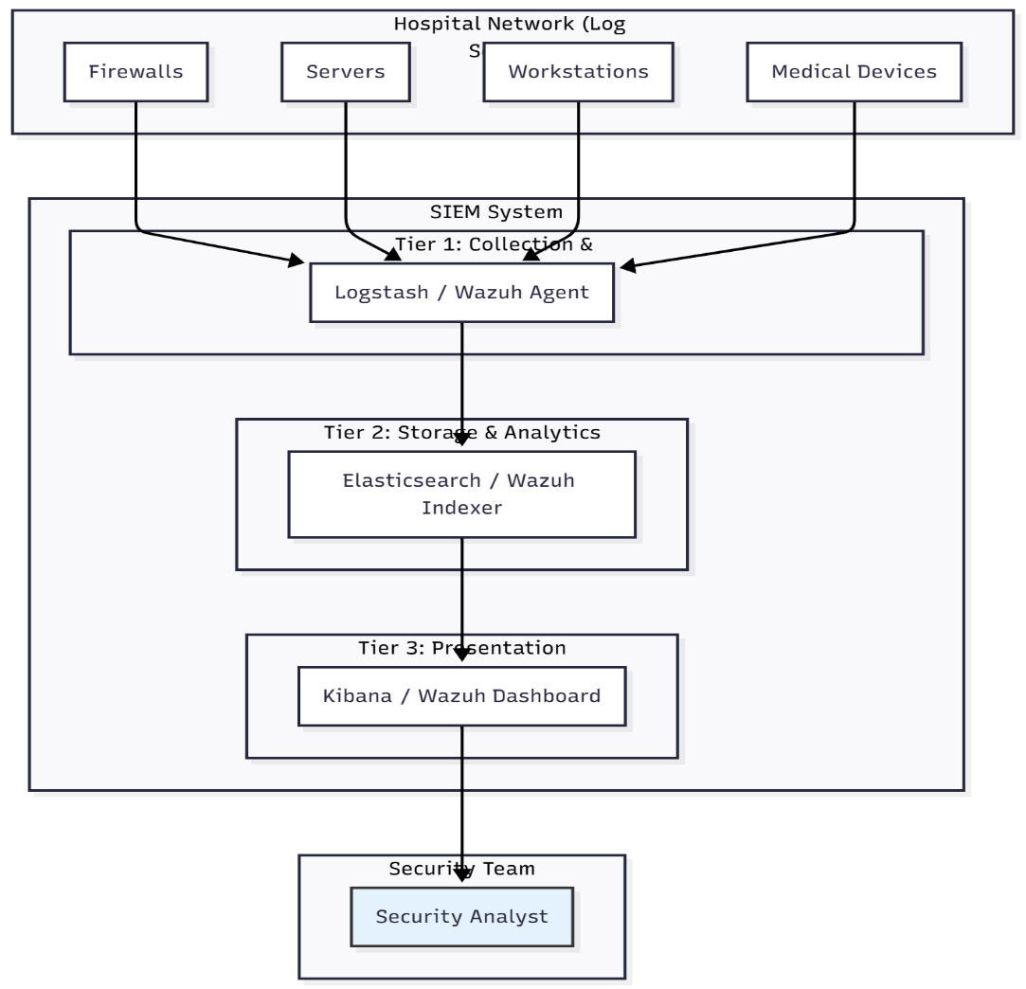
Figure 1 SYSTEM ARCHITECTURE

1.6.3.2. Use Case Diagram
This Use Case diagram shows the primary interactions between the Security Analyst (the main actor) and the SIEM system. The analyst uses the system to Monitor Dashboards for a high-level security overview, Investigate Alerts triggered by suspicious activity, Analyze Log Data to perform deep-dive forensics, and Generate Reports for compliance and management review. These functions cover the complete workflow of a security operations professional.
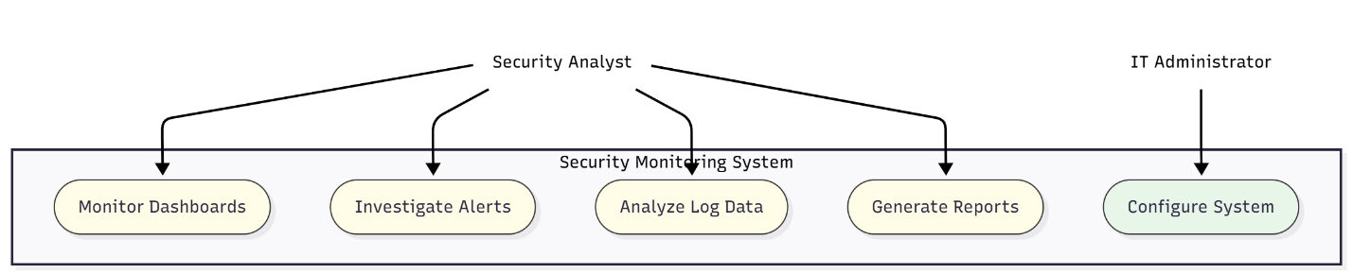
Figure 2 USE CASE DIAGRAM

1.6.3.3. Sequence Diagram
This Sequence Diagram details the process of how the SIEM system detects and alerts on a security event, such as multiple failed login attempts. A Malicious Actor attempts to log in to a Server, which generates log entries. The Log Agent on the server forwards these logs to the SIEM Engine. The engine correlates these events, and once a predefined threshold is met, it identifies a threat and sends an Alert to the Security Analyst for investigation.
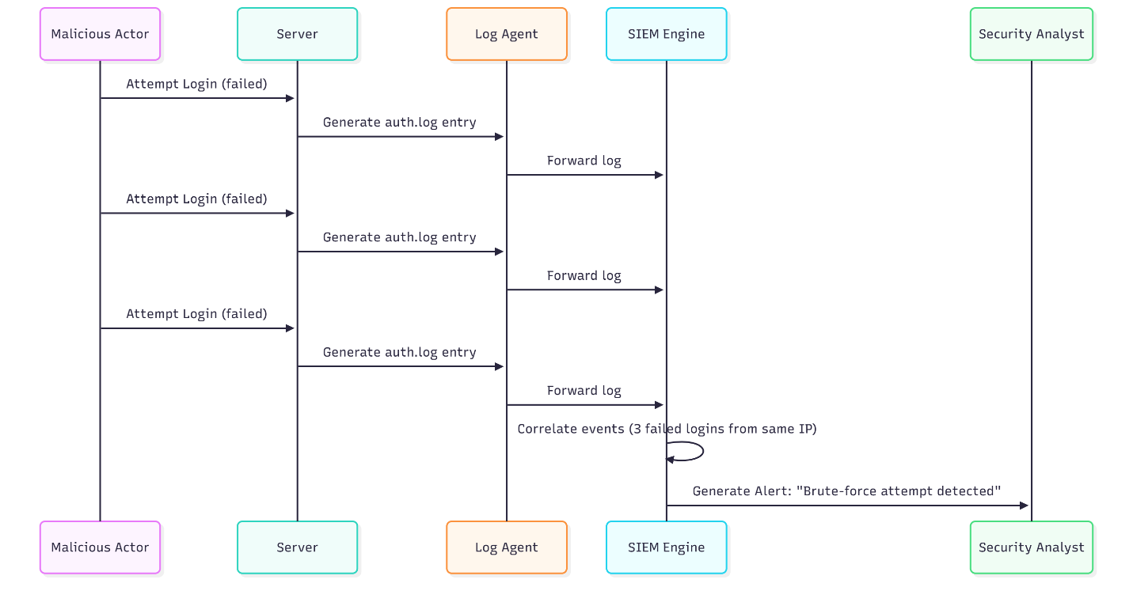
Figure 3 SEQUENCE DIAGRAM

1.6.3.4. User Interface Design
The SIEM user interface will be clean, role-aware, and task-focused so security analysts and administrators can act quickly. A central responsive dashboard will present a real-time security overview with key metrics (active alerts, open incidents, top affected hosts, and recent critical events), an alerts panel with quick actions (acknowledge, assign, escalate), an investigations view for drilling into correlated events and raw logs, and a reporting area for scheduled and on-demand compliance exports. Access will be role-based so analysts see investigation and alerting tools while administrators have configuration and data-source management controls. The UI will be delivered through the SIEM’s web console (e.g., Kibana/Wazuh) and improved by custom front-end components stored in the project’s GitHub repository; configuration files, dashboard definitions, and visualization code will be versioned in GitHub to enable repeatable deployments and collaborative tuning. Usability will follow established heuristics to minimize cognitive load and accelerate incident response (Nielsen, 1994).

1.7 Proposed solution development
The proposed solution development approach emphasises repeatability, security, testability and an operational handover. The implementation will produce a set of deployable artefacts—infrastructure as code, agent and pipeline configurations, parsers, dashboard exports, alerting rules, CI/CD pipelines and operational runbooks—that together enable Korle-bu’s IT team to operate or sustainably outsource the SIEM capability. Development will follow an Agile cadence with two-week sprints, giving early value by integrating the highest-priority log sources first and iteratively expanding coverage while tuning correlation rules and refining dashboards. All configurations will be managed as code in a versioned repository, secrets will be injected at runtime via a vault, and unit and integration tests will be executed automatically in CI to reduce configuration drift and deployment risk. The development process will also include staged environments (local, staging/UAT and production) to validate functionality, performance and security before any production cutover, coupled with documentation and structured knowledge transfer to ensure a smooth operational transition.

1.7.1 Development technology and tools specifications
The technology stack and toolchain have been selected for operational maturity, community support and ease of maintenance. Core analytics and storage will be provided by an established SIEM/ELK solution (Wazuh or Elasticsearch/Logstash/Kibana) with Beats or Wazuh agents for secure telemetry collection. Python will be the primary language for parsers, test harnesses and automation scripts because of its extensive libraries and test frameworks; Bash will support operational scripting and Node.js may be used for lightweight microservices or custom UI components where required. Infrastructure provisioning and configuration management will be implemented using Terraform and/or Ansible, with Git-based source control and CI pipelines (GitHub Actions or GitLab CI) to automate linting, unit tests, configuration validation and deployment to staging. Development environments will standardise on IDEs such as Visual Studio Code with linters and pre-commit hooks to enforce code quality. For secrets and certificates, an approved vault solution and an internal PKI are recommended.

1.7.1.1 Software including programming language, IDE and runtime platforms
The software platform comprises the SIEM engine (Wazuh or Elastic Stack) and telemetry agents (Filebeat, Winlogbeat, Metricbeat, Wazuh agents) running on a stable Linux distribution for servers and appropriate agent packages for endpoints. Python 3.9+ will be the primary language for parsing, ingestion helpers and test code, supported by pytest for unit testing. Development and operations will use Git for version control, with GitHub Actions or GitLab CI for pipelines. Docker and Docker Compose will be used for local development and integration testing, while Kubernetes may be used for production orchestration if required. Tooling will include linters (flake8, yamllint), static validators for Logstash/agent configurations and monitoring stacks (Prometheus/Grafana or Elastic Monitoring) for cluster metrics.

1.7.1.2 Hardware (development and production)
Development machines should be standard developer workstations (minimum 16 GB RAM, quad-core CPU, 512 GB SSD). A staging/UAT cluster should emulate production with a small set of VMs or containers (for example, three nodes with 8–16 GB RAM each) to validate HA and failover behaviours. Production sizing will be driven by the measured events-per-second (EPS) baseline but a minimal recommended on-premises cluster example is three data nodes (32–64 GB RAM, 8+ vCPU, 1–2 TB NVMe each) and three master nodes (8–16 GB RAM) with dedicated ingest/coordinating nodes as needed; object storage or S3-compatible storage is recommended for snapshots and long-term retention. Network infrastructure should provide low-latency connectivity (10GbE between nodes recommended for high EPS) and VLAN-capable switching for segmentation; redundant firewalls and jump hosts are required for secure administrative access.

1.7.2 Network specifications and deployment considerations
All log transport must be secured using TLS and authenticated channels. Agent-to-ingest communications (Beats -> Logstash/Wazuh Manager) should use encrypted TCP (for example TLS on 5044), and device syslog should be forwarded over TCP/TLS (RFC 5424, port 6514) where supported. Network design must include a dedicated logging VLAN/subnet with ACLs restricting access to authorised management hosts and monitoring systems; management access to the logging environment should be via VPN or bastion hosts only. Capacity planning must be driven by a measured EPS baseline with a 2–3x headroom for bursts, and ingestion nodes and storage must be provisioned accordingly. High availability is achieved through redundant ingestion endpoints, Elasticsearch shard replication and regular snapshot schedules to remote storage. Accurate time synchronisation using NTP or chrony across all hosts is mandatory to preserve event ordering and forensic integrity. Data handling and retention policies must be defined to balance forensic needs with privacy obligations; where feasible, patient identifiers in logs should be tokenised or masked for analytics while retaining sufficient context for incident investigation.

1.7.2.2 Developed solution and associated code
The delivered repository will contain modular, production-ready artefacts: infrastructure provisioning code (Terraform/Ansible), container images and compose files for local staging, agent configurations for Filebeat/Wazuh, Logstash pipelines with parsing and ECS mapping, Elasticsearch index templates and ILM policies, exported dashboards and saved objects for Kibana/Wazuh UI, Python parser modules with unit tests, CI pipeline definitions and operational runbooks. Configuration files will be parameterised so secrets are never committed, and CI will validate syntax and run unit tests before merging. Example parser modules (for HL7, syslog and firewall formats), test cases and dashboard exports will be provided to accelerate onboarding and enable repeatable deployments across environments.
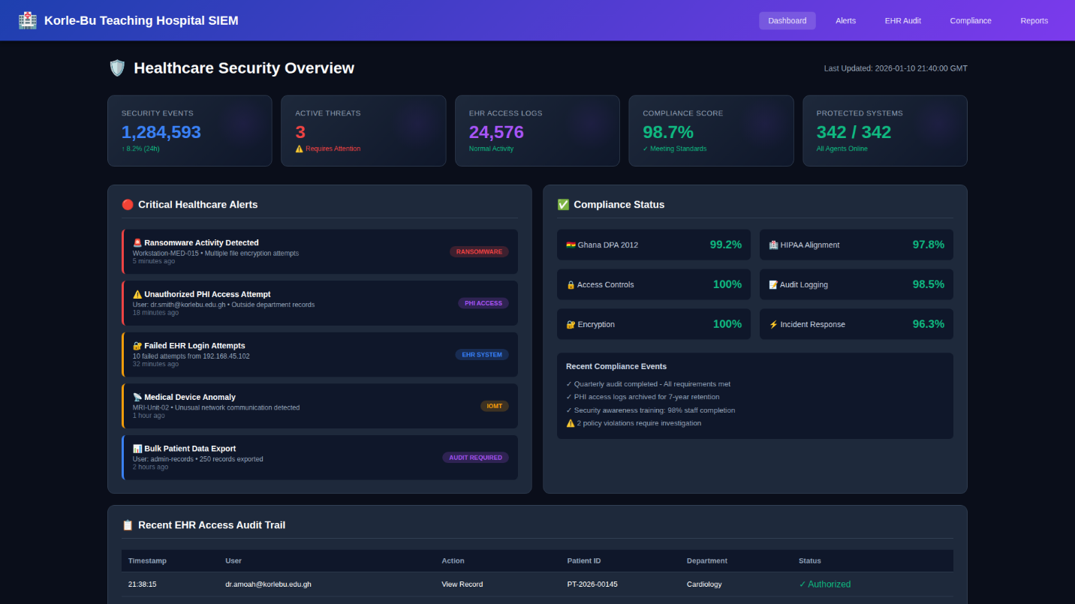
Figure 4 HEALTH CARE SECURITY DASHBOARD
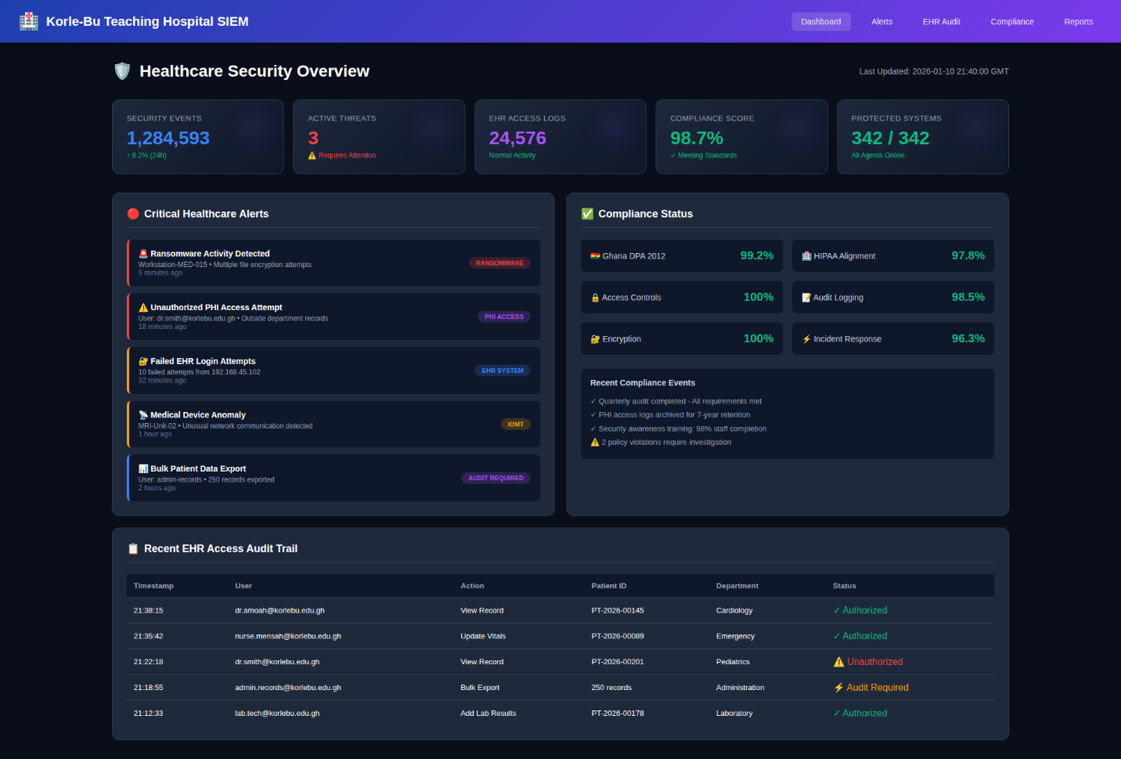
Figure 5 COMPLETE SIEM VIEW
Figure 6 HEALTH CARE METRICS
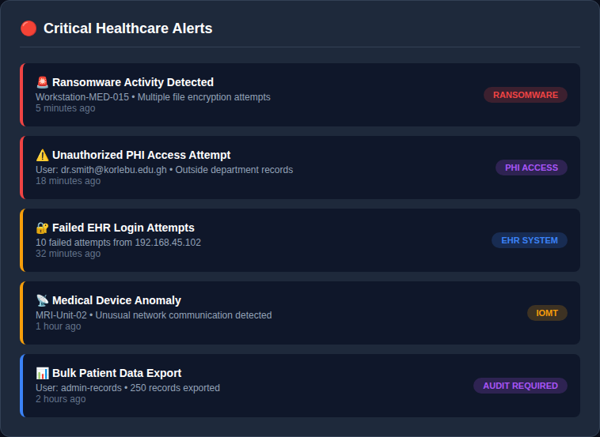
Figure 7 CRITICAL-HEALTH-CARE-ALERTS
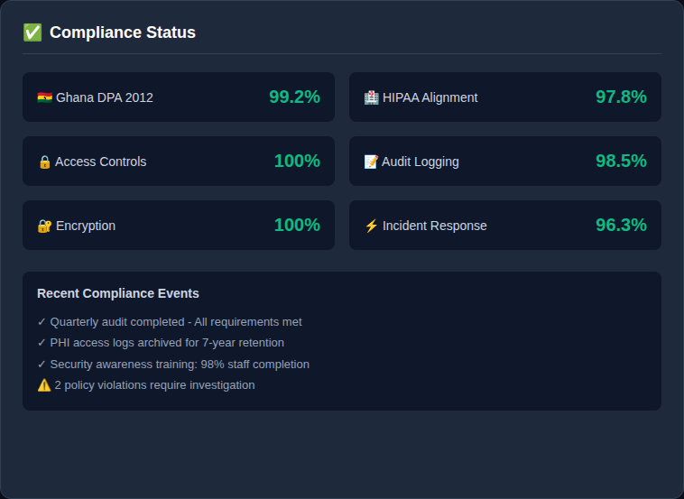
Figure 8 COMPLIANCE-STATUS
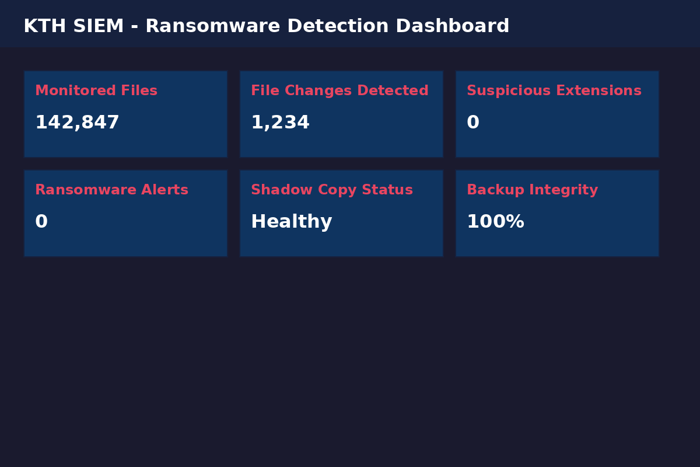
Figure 9 RANSOMWARE-DETECTION-DASHBOARD
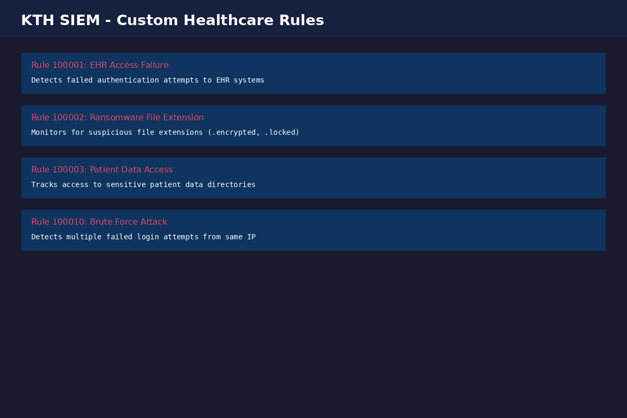
Figure 10 HEALTH-CARE-SECURITY-RULES
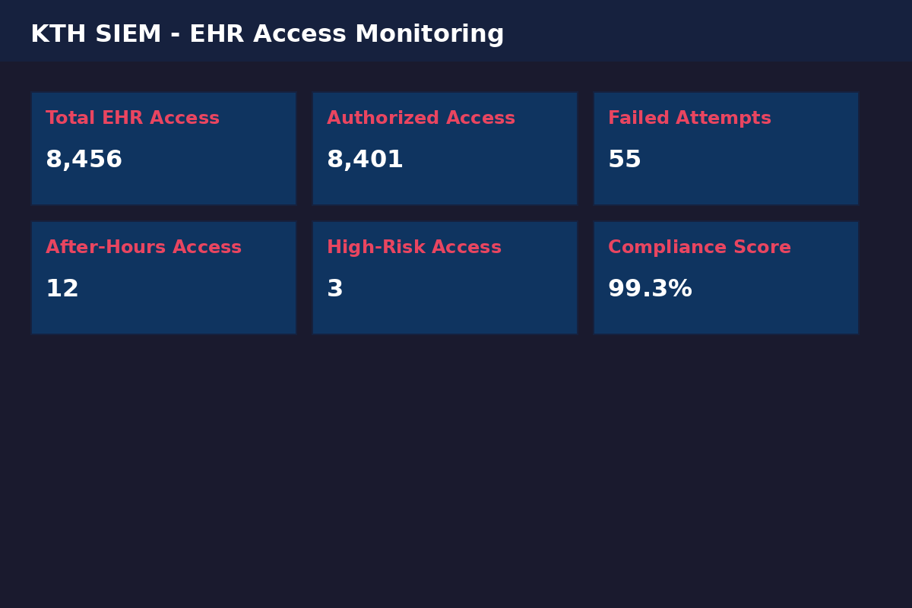
Figure 11 ERH-ACCESS-MONITORING-RULES
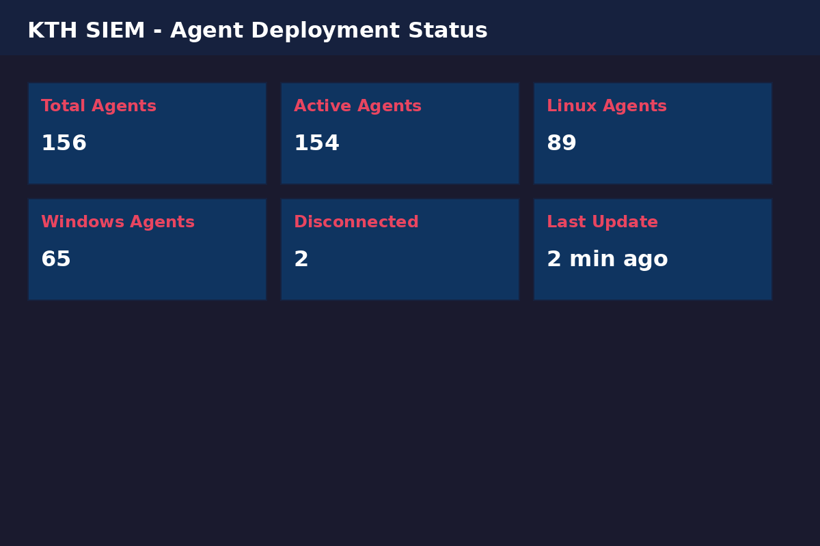
Figure 12 AGENT-DEPLOYMENT-STATUS
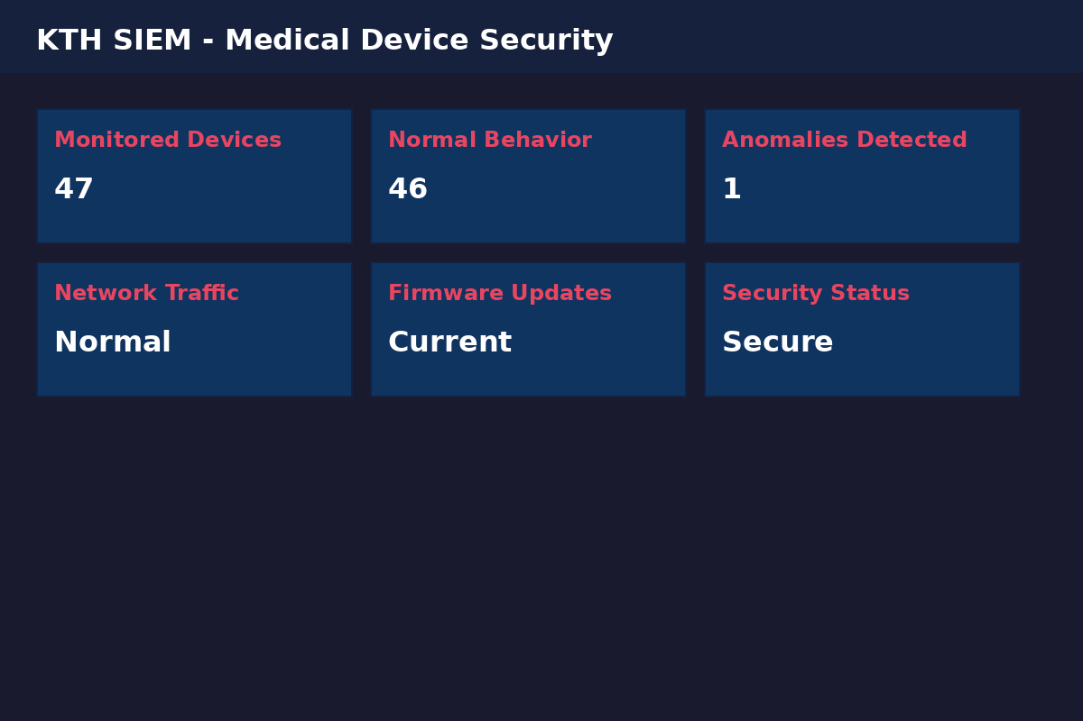
Figure 13 MEDICAL-DEVICE-SECURITY

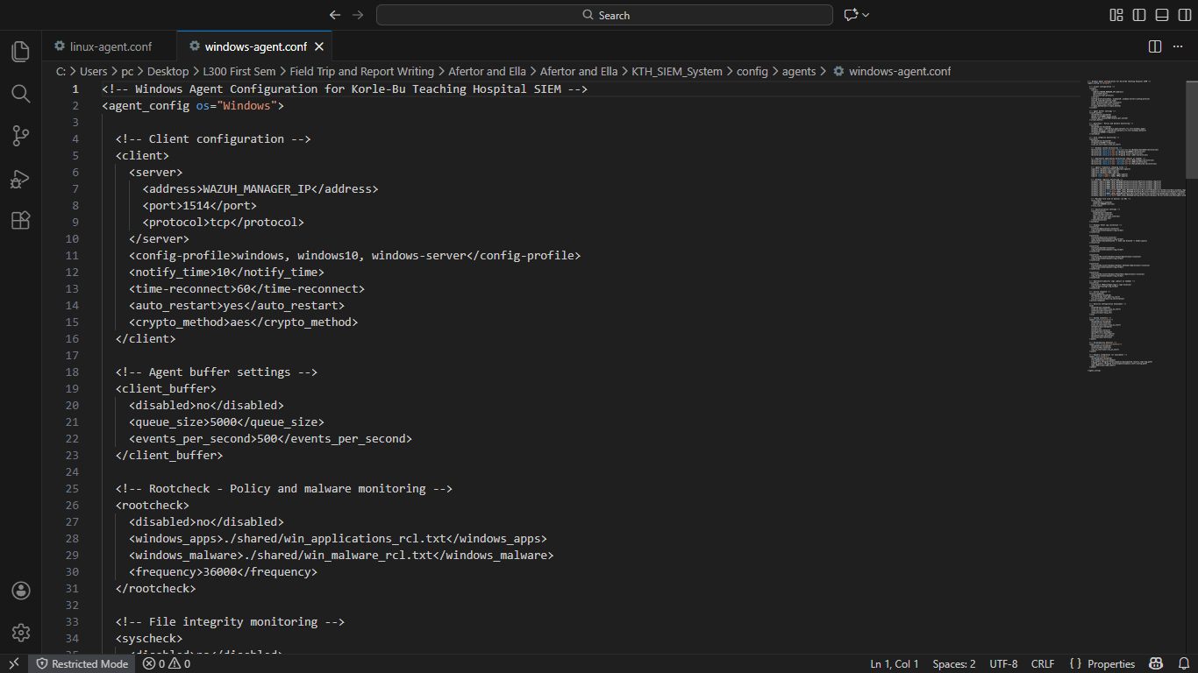
Figure 14 CONFIG-AGENT-WINDOWS
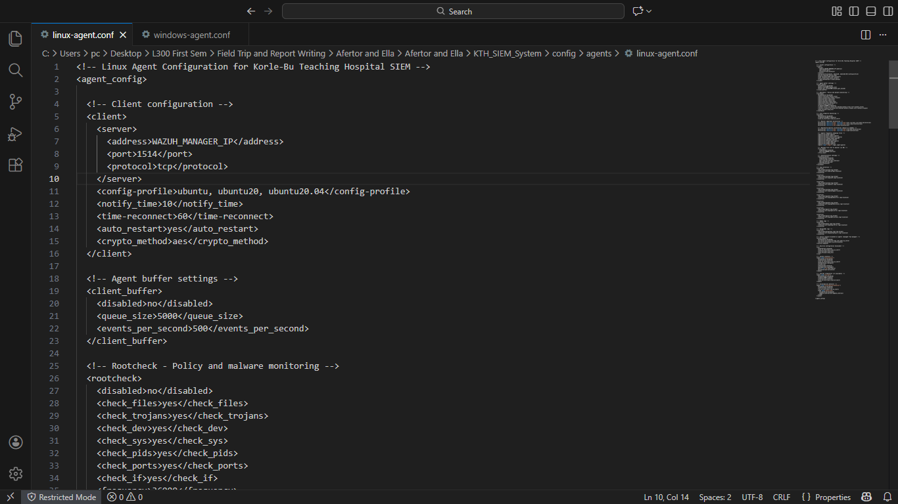
Figure 15 CONFIG-AGENT-LINUX
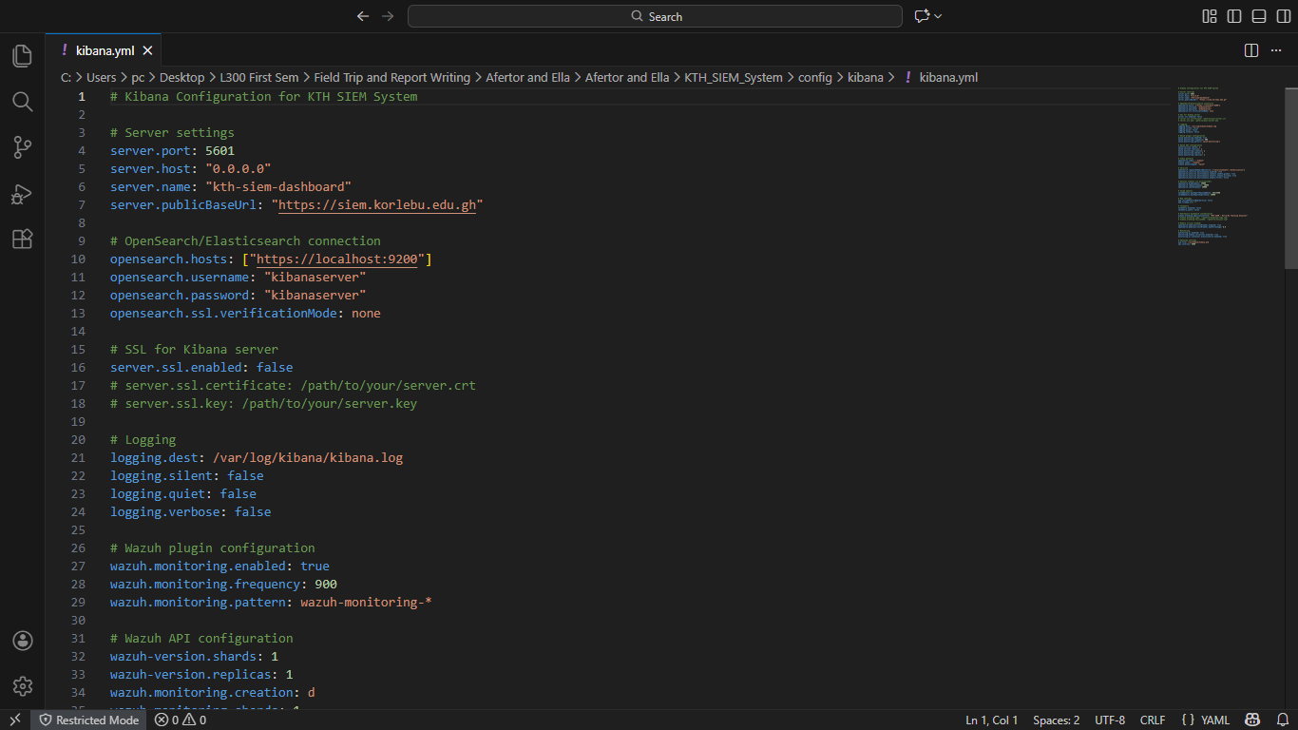
Figure 16 CONFIG-KIBANA

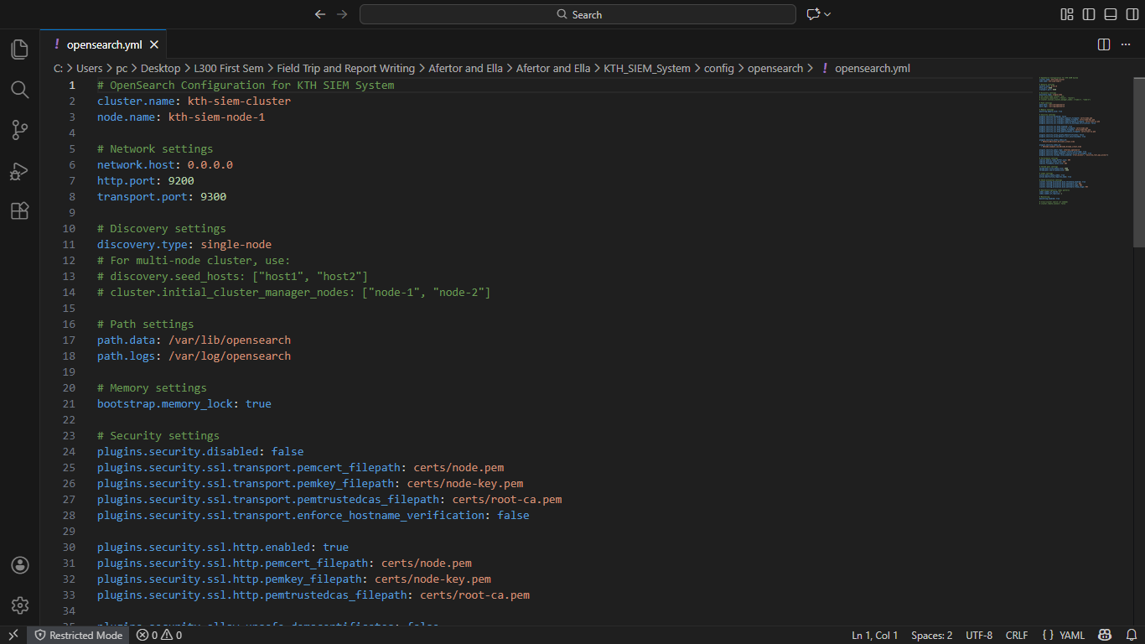
Figure 17 CONFIG-OPENSEARCH

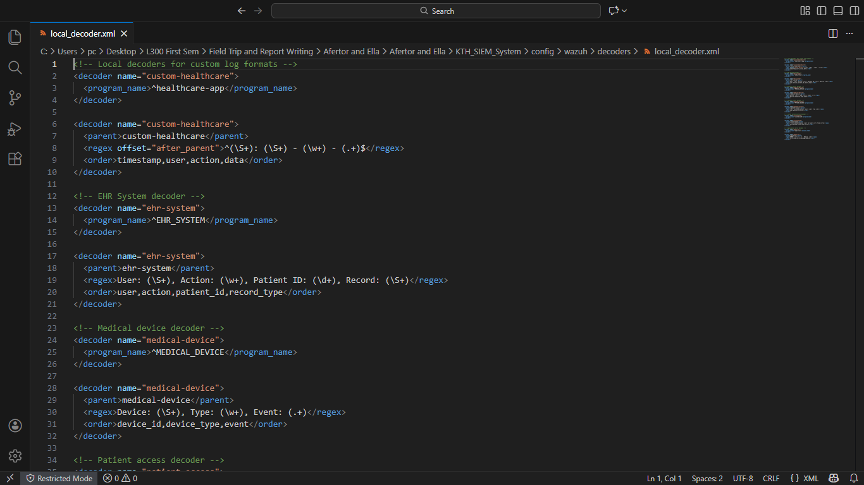
Figure 18 CONFIG-WAZUH-LOCAL-DECODER

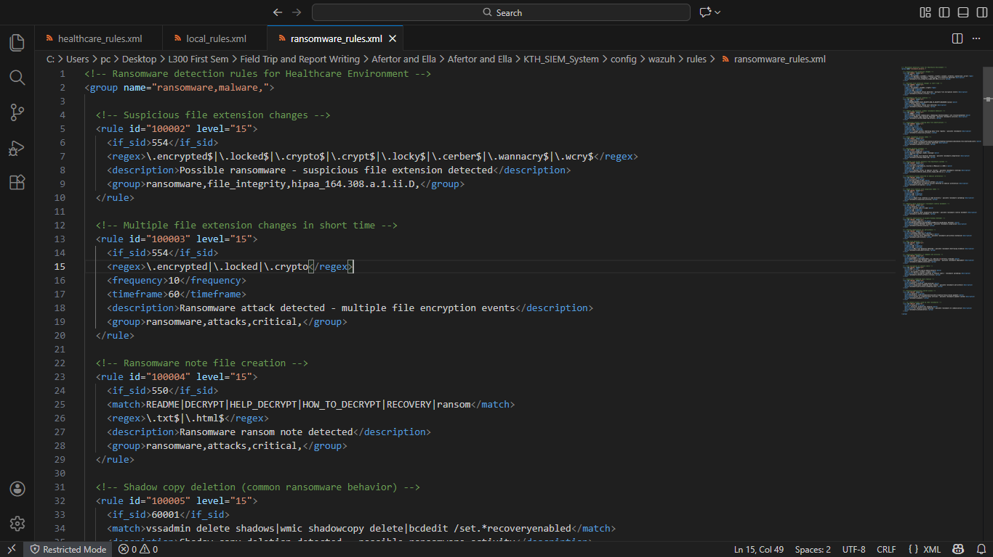
Figure 19 CONFIG-WAZUH-RULES-RANSOMWARE-RULES
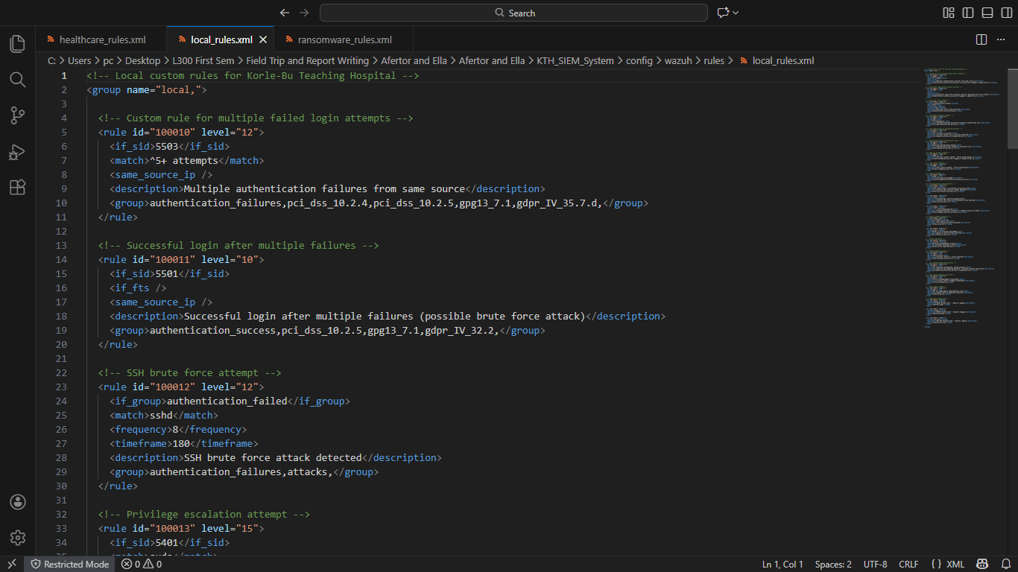
Figure 20 CONFIG-WAZUH-RULES-LOCAL-RULES

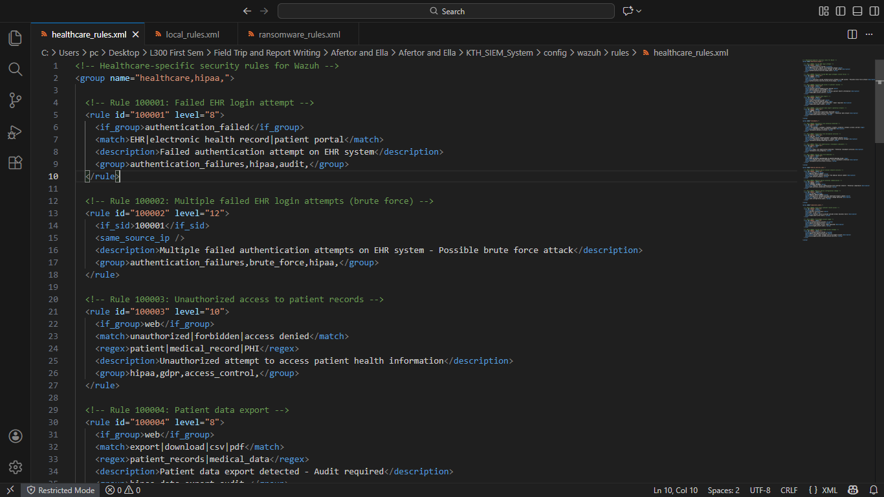
Figure 21 CONFIG-WAZUH-RULES-HEALTH-CARE-RULES

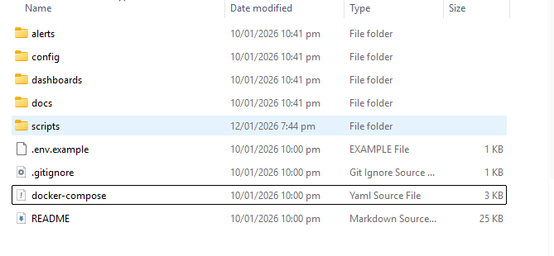
Figure 22 PICTURE-OF-OTHER-FILES

1.8 System testing
A staged testing program will validate the system against functional and non-functional requirements before production deployment. Testing is organised into unit, integration and system testing phases, executed in a staging environment that mirrors production.

1.8.1 Unit test
Unit testing will validate parsing logic, transformation utilities and configuration snippets in isolation to ensure deterministic behaviour and prevent pipeline failures. Parser functions (e.g., HL7, firewall, syslog) will be covered by pytest unit tests with a target coverage threshold for critical parsing code, and YAML/JSON configuration files will be validated by schema checks and linters. Acceptance criteria for unit testing include successful passing of all unit tests in CI and no configuration failures prior to deployment.

1.8.2 Integration testing
Integration testing will verify end-to-end telemetry flow from agents through processing and indexing to visualization and alerting, including authentication, RBAC enforcement and delivery of alerts to configured endpoints. A Docker Compose or Kubernetes staging stack will be used to orchestrate the full pipeline while synthetic log generators and replay tools simulate normal operations and attack scenarios. Integration acceptance criteria include indexability and discoverability of events within defined SLAs (for example, recent events searchable within five seconds), successful triggering and delivery of configured alerts for test scenarios, and correct rendering and drilldown behaviour for dashboards.

1.8.3 System testing
System testing will validate performance, resilience, security and recoverability under realistic operational conditions. Load and performance will be measured using benchmarking tools (Elasticsearch Rally, JMeter or custom generators) to confirm the architecture meets EPS and query latency targets under sustained and burst conditions. Resilience tests will simulate node failures and network partitions to verify cluster failover and recovery procedures, while security validation will include vulnerability scanning, TLS configuration checks, RBAC testing and controlled penetration testing in staging. Backup and restore tests will confirm snapshot integrity and recovery time objectives. Acceptance criteria for system testing include maintained ingestion latency and query responsiveness under target loads, successful recovery to a healthy cluster state within defined recovery windows after simulated faults with no data loss beyond the RPO, and remediation or scheduling of remediation for critical security findings prior to production rollout.

References
Ghana, 2012. Government of Ghana Data Protection Act, 2012 (Act 843). Accra: Ghana Publishing Company.
Nielsen, J., 1994. 10 Usability Heuristics for User Interface Design. [Online]
Available at: https://www.nngroup.com/articles/ten-usability-heuristics/
[Accessed 5 December 2025].
Sommerville, I., 2016. Software Engineering, Global Edition. In: Software Engineering. s.l.:Pearson Higher Ed, 2016.

